[CEN 323 ] Computer Organization & Assembly Language
Lab 2 Journal

Name : Bilal Aamir
Enrollment Number: 01-135232-016

Lab Deliverables (submission guideline)

Create a folder named after your enrollment number and add the following files:
  - Create a folder named YourRollNumber_Lab2 containing:
- .asm files of all tasks.
- Add the following to the lab journal.
  - Full-screen screenshots of code.
  - Full-screen screenshots of output.
  - Code text.

  - Zip the Folder and upload to LMS.

Lab Task

Task 1:
Code (TEXT):
.data
input db ?
str db "Enter the character you want to print ","$"

.code
main:

mov ah,02h
mov dl,'c'
int 21h

mov dl,10
int 21h

mov ax,@data
mov ds,ax

mov ah,09h
LEA dx,str
int 21h

mov ah,1
int 21h

mov input,al

mov ah,02h

mov dl,10
int 21h

mov dl,input
int 21h

mov ah,4Ch
int 21h
end main

Screenshot (CODE):
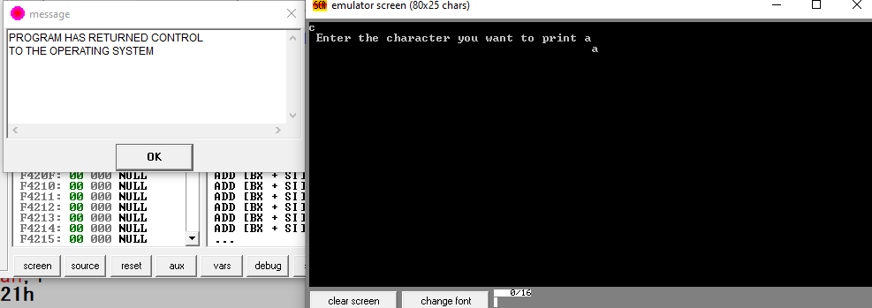

Screenshot (OUTPUT):

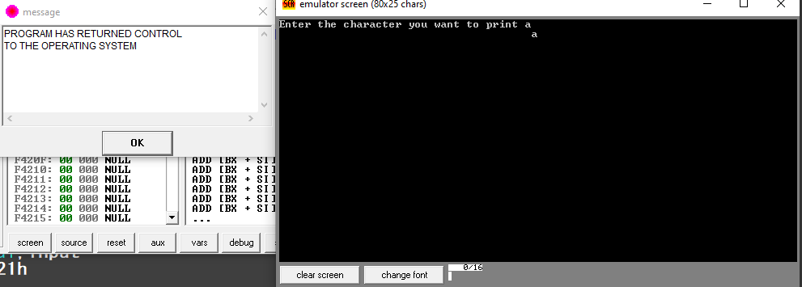

Task 2:
Code (TEXT):
.data

msg db " *" ,10,13,
db " ***" ,10,13,
db " *****" ,10,13,
db " *******" ,10,13,
db " ***** " ,10,13 ,
db " *** ",10,13 ,
db " * ",10,13, "$"

.code
main:
mov ax,@data
mov ds,ax

mov ah,09h
LEA dx,msg
int 21h

mov ah,4Ch
int 21h
end main

Screenshot (CODE):
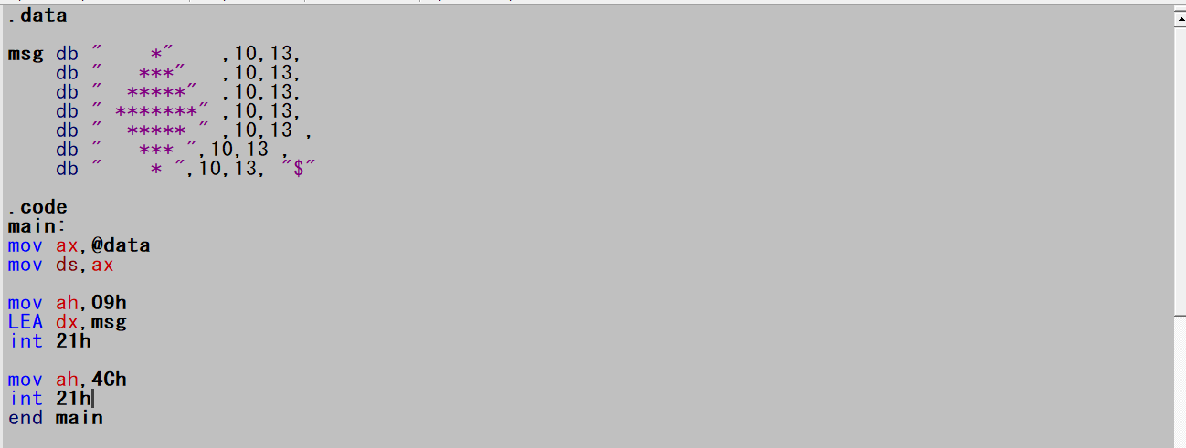

Screenshot (OUTPUT):
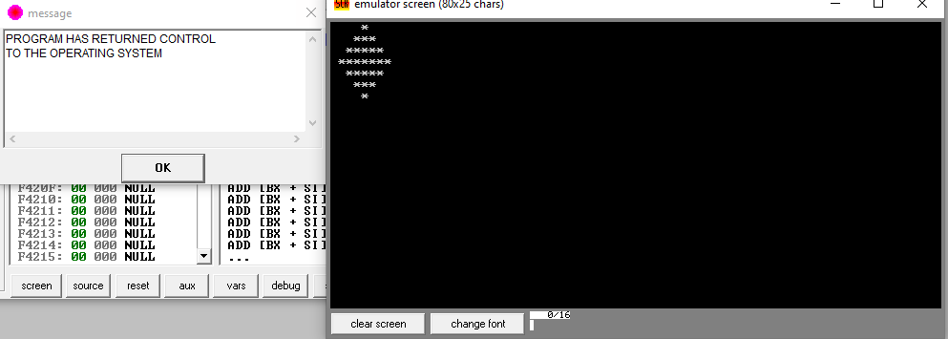

Task 3:
Code (TEXT):
.data
str1 db "2x 1 = $"
str2 db "2x 2 = $"
str3 db "2x 3 = $"
str4 db "2x 4 = $"
str5 db "2x 5 = $"
str6 db "2x 6 = $"
str7 db "2x 7 = $"
str8 db "2x 8 = $"
str9 db "2x 9 = $"
str10 db "2x 10 = $"
int1 db 2
int2 db 4
int3 db 6
int4 db 8
int5 db 10
int6 db 12
int7 db 14
int8 db 16
int9 db 18
int10 db 20

space db 9
newl db 10,13,"$"

.code
main:
mov ax,@data
mov ds,ax

mov ah,09h
LEA dx,str1
int 21h

mov ah,02h
mov dl,space
int 21h

mov dl,int1
add dl,48
int 21h

mov dx,offset newl
mov ah,09h
int 21h

;New Line

mov ah,09h
LEA dx,str2
int 21h

mov ah,02h
mov dl,space
int 21h

mov dl,int2
add dl,48
int 21h

mov dx,offset newl
mov ah,09h
int 21h

;New Line

mov ah,09h
LEA dx,str3
int 21h

mov ah,02h
mov dl,space
int 21h

mov dl,int3
add dl,48
int 21h

mov dx,offset newl
mov ah,09h
int 21h

;New Line

mov ah,09h
LEA dx,str4
int 21h

mov ah,02h
mov dl,space
int 21h

mov dl,int4
add dl,48
int 21h

mov dx,offset newl
mov ah,09h
int 21h

;New Line

mov ah,09h
LEA dx,str5
int 21h

mov ah,02h
mov dl,space
int 21h

mov dl,49
int 21h

mov dl,48
int 21h

mov dx,offset newl
mov ah,09h
int 21h

;New Line

mov ah,09h
LEA dx,str6
int 21h

mov ah,02h
mov dl,space
int 21h

mov dl,49
int 21h

mov dl,50
int 21h

mov dx,offset newl
mov ah,09h
int 21h

;New Line

mov ah,09h
LEA dx,str7
int 21h

mov ah,02h
mov dl,space
int 21h

mov dl,49
int 21h

mov dl,52
int 21h

mov dx,offset newl
mov ah,09h
int 21h

;New Line

mov ah,09h
LEA dx,str8
int 21h

mov ah,02h
mov dl,space
int 21h

mov dl,49
int 21h

mov dl,54
int 21h

mov dx,offset newl
mov ah,09h
int 21h

;New Line

mov ah,09h
LEA dx,str9
int 21h

mov ah,02h
mov dl,space
int 21h

mov dl,49
int 21h

mov dl,56
int 21h

mov dx,offset newl
mov ah,09h
int 21h

;New Line

mov ah,09h
LEA dx,str10
int 21h

mov ah,02h
mov dl,space
int 21h

mov dl,50
int 21h

mov dl,48
int 21h

mov ah,4Ch
int 21h
end main

Screenshot (CODE):
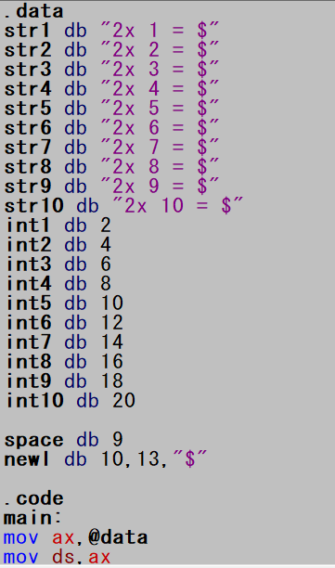

Screenshot (OUTPUT):

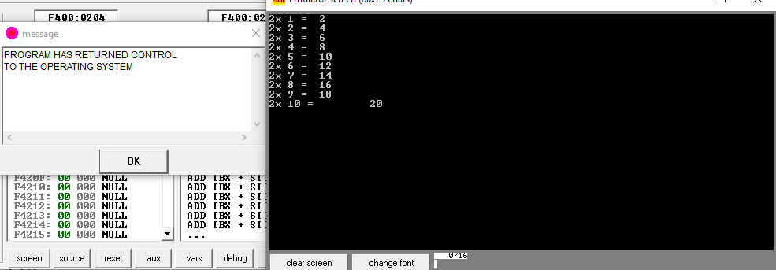

Unseen Task
Code
.data
str1 db "Enter the first Number :","$"
str2 db "Enter the second Number :","$"
num1 db ?
num2 db ?
newl db 10,13,"$"
.code
main:

mov ax,@data
mov ds,ax

mov ah,09h
LEA dx,str1
int 21h

mov ah,01h
int 21h
mov num1,al

mov ah,09h
LEA dx,newl
int 21h

LEA dx,str2
int 21h

mov ah,01h
int 21h
mov num2,al

mov dl,num2
add dl,num1

sub dl,48

mov ah,09h
LEA dx,newl
int 21h

mov ah,02h
int 21h

mov ah,4Ch
int 21h
end main
Code Picture
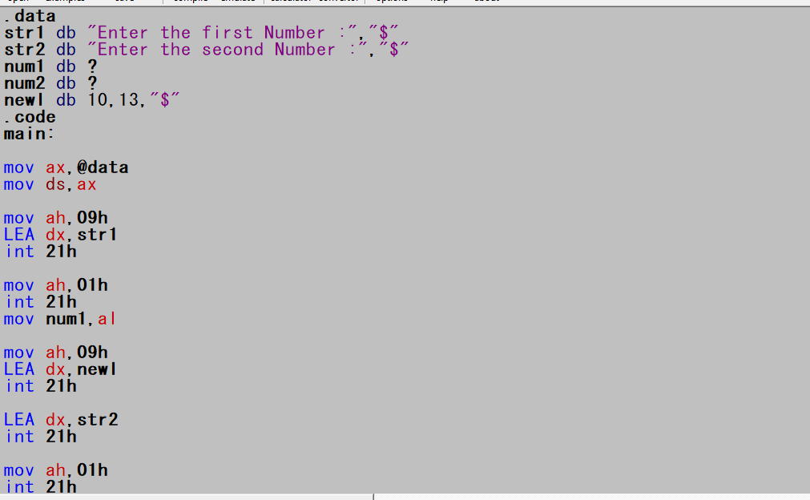
Output
